SAFETY ENSURED
With CONDAT products

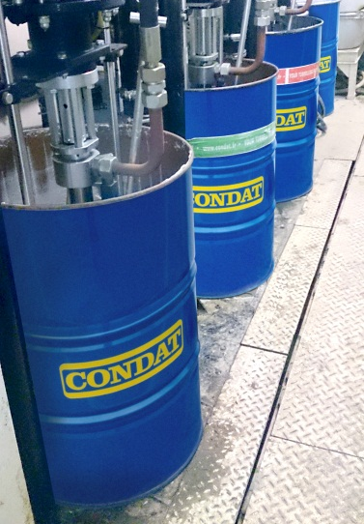
CONDAT has been supplying the tunnelling market for more than 20 years with high performing products suitable for any working conditions.

CONDAT latest innovation contributes to make jobsites safer.
CONDAT is the worldwide unique supplier of a complete range of self-extinguishing products dedicated to tunnellers, comprising:
- Tail-end sealants and first-packing sealant: WR 89 NewGeneration et WR90 NewGeneration
- Greases : GR 217 S EP
- Hydraulic fluids: CONDAT D46/68

And from June 2014
- The sealing compound for the main bearing of the TBM: HBW NewGeneration
which extinguishes itself after having been in contact with a flame (CNPP test).

CONDAT products are perfectly adapted to TBM constraints of maintenance and productivity. They contribute to optimum safety of the jobsite thanks to their high performance level, to their fire resistance properties and to their low environmental impact (readily biodegradable and not classified as dangerous for humans and the environment)

HBW New Generation
A unique sealing product for the TBM main bearing which is both biodegradable* and self-extinguishing.

From June 2014, CONDAT proposes a substitute to HBW: HBW NewGeneration, which combines the recognized performance of HBW with self-extinguishing properties.

HBW NewGeneration tests

Not dangerous for humans and the environment
Environmental Risk Assessment achieved by BMG
OECD 201/ 202 / 203 / 423

*Readily biodegradable
OECD 301D

Fire Risk Assessment
CNPP test

HBW NewGeneration was specifically formulated and designed to ensure sealing but also compensate for coaxiality problems.

Its adhesion, density, consistence and seal lubricating properties provide perfect sealing of rotating components in the TBM’s head, preventing any water, ground or impurity ingress and granting full integrity of the system.

It fulfills the necessary criteria of:
- pumpability
- injectability in order to perfectly fill the labyrinth
- Resistance to water spray-off and adhesion to wet surfaces

HBW NewGeneration is of course fully compatible and miscible with the CONDAT extreme pressure grease ranges GR 130, GR 217 and GR 217S–the latter being also self extinguishing- which are used jointly with HBW in order to lubricate the lips seals. The use of these two products guarantees optimum performance.

HBW NewGeneration has been designed and tested in collaboration with many OEM (TBMs manufacturers) and simply replaces HBW giving a significant improvement to fire safety.

Since more than 20 years, CONDAT has developed a complete range of products, lubricants and additives fulfilling technical safety and environmental requirements for underground works with TBM. A technical team is specially dedicated to the good use of these products on any type of TBM worldwide.

Press contact
Nathalie VIDAL - Communication Manager - 104 Avenue Frédéric Mistral - BP 16 - F -38670 CHASSE-SUR-RHÔNE
Tél. : 33 4 78 07 37 11 - Fax : 33 4 78 07 35 39 - nathalie.vidal@condat.fr

